All-CUNY Open Access Meetup!
Have you heard chatter about "Open Access"?
"Open Access" (OA) refers to works that are accessible at no cost on the internet and available for all to read, download, print, copy, share, etc.
Sound good? It is! Sound too good to be true? It's not!

All members of the CUNY community are invited to attend the All-CUNY Open Access Meetup on March 26. At this meeting, we plan to have a discussion about open access textbooks and other curricular materials. How can we make high-quality course materials available to our students at no cost?

We welcome further items for discussion and action at these meetings, and plan to hold a monthly meetup in a central location—if you can’t make this meeting, stay tuned for further details.
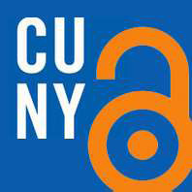
March 26, 2012
3-5pm
CUNY Graduate Center
Mina Rees Library
Lower Level, Room C196.05
All are welcome!

For more information about upcoming meetings and Open Access issues:
http://commons.gc.cuny.edu/groups/oapn/
http://openaccess.commons.gc.cuny.edu/

